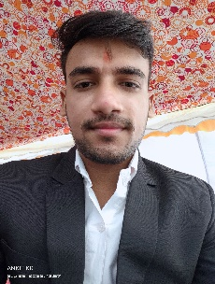**RESUME**

**ANKIT KUMAR KUSHWAHA**

91+ 96083 32286

Email Id: [ankitkumarkushwaha53@gmail.com](mailto:ankitkumarkushwaha53@gmail.com)

**OBJECTIVE**

To work with an organization where can learn new skills and increase my abilities for the organizational goal as well as myself.

**EDUCATIONAL QUALIFICATION**

* Pursing B.tech (CSE) 3rd year from Dr.MGR University
* Passed out 12th from BSEB in 2021
* Passed out 10th from BSEB in 2019

**TECHNICAL SKILLS**

* Programming language : C , PYTHON
* Framework : BOOTSTRAP
* Front End Technologies :HTML, CSS, JAVASCRIPT

**WORK EXPERIENCE**

* Fresher

**SKILLS**

* Communication Skill
* Ability to work independently
* Curiosity to learn new

**PERSONAL DETAILS**

Father’s name : Yogendra Mandal

Date of Birth : 01 Jan 2003

Gender : Male

Material Status : Single

Nationality : Indian

Languages Known : English , Hindi

Hobbies : Listen Song

**Declaration :** I do hereby declare that the above information is true to the best of my knowledge and belief.